33.50: A quarter-wave plate shifts the phase of the light by 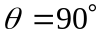. Circularly polarized light is out of phase by 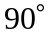, so the use of a quarter-wave plate will bring it back into phase, resulting in linearly polarized light.

